Purpose / Scope:
Timing and action plan to run project planning with the SEP matrix (maturity gates RG1-RG7) in PLM2 for all customer projects from RFQ to series. Standards: IATF 16949 8.3.2, 8.3.2.1, 8.3.4, 8.3.4.4; VDA MLA; VDA 6.3 P2-P4.
Owner / involved:
- C. Demmler, Process Development: owner of PLM2 and of every action in this plan, author, keeps it current
- Program Management and APQP: support (specification, tests, pilots on the running projects, evidence)
- Departments named per action (IT, Quality, Development, Tooling, HR, department heads): support where their part is needed
- Plant Management: monthly status review
1. Summary
The SEP matrix is fully in PLM2: seven maturity gates with 232 items, the same content as the group template GB-DP-0001, created for every project. What remains is uploading the evidence of the running projects. Project 1994 (Brose Seat Trim, nominated 09/21/2026) is the lead project: it runs every gate in PLM2 up to SOP, and the rules tighten with it. From 01/18/2027 new projects start in PLM2 only.
2. Requirements and how they are met
Requirement | How it is met | What we show
Design and development planning, multidisciplinary (8.3.2, 8.3.2.1) | SEP matrix per project; every item has a responsible function and a status (open, done, not applicable) | SEP tab of project 1994
Monitoring at defined stages (8.3.4) | Gates close in order; closing needs PM and Quality sign-off and locks the items | Gate status, sign-off record
Product approval process (8.3.4.4) | Pre-series gate B/RG6 and series gate A/RG7 carry the approval items | Gates RG6 / RG7
Documented evidence | Files attached per SEP item; every item change audited field by field | Documents tab, item history
Maturity level logic (VDA MLA) | Gates K0/RG1 to A/RG7 follow the maturity levels | SEP matrix

3. Process flow
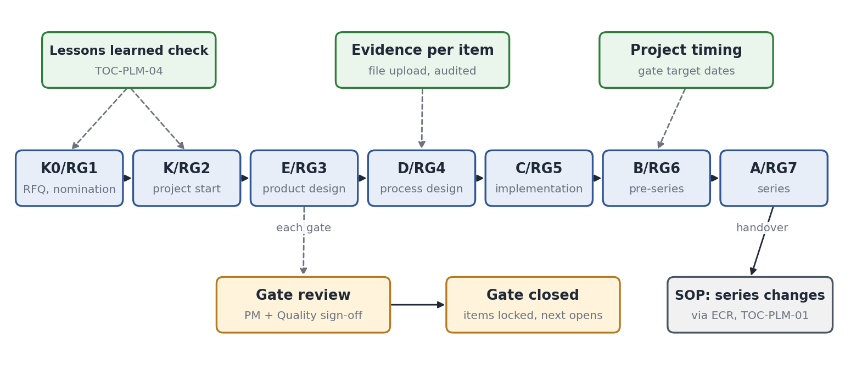
- A gate opens only after the previous one is closed. Items are done or marked not applicable with a reason; nothing is skipped silently.
- Lessons learned are checked at RG1 and RG2 (TOC-PLM-04); evidence is filed on the item it proves.
- At SOP (A/RG7) the project hands over to series: from then on every change runs through TOC-PLM-01.
4. Project overview
A project overview page (action S1) shows every active project on one screen: current gate, gate target date, items open and overdue, open changes and open lessons. It is the page used in the monthly review and shown first in an audit. SEP items with an owner and due date appear in the owner's task list like change tasks (TOC-PLM-01, section 4).
5. Where we stand today
Element | Status | Evidence in PLM2
SEP matrix, 7 gates / 232 items per project | Built | Projects 1864, 1994, 2141, 2277
Dual sign-off and item lock at gate close | Built | Gate close dialog
File evidence per item, field audit | Built | Documents tab, item history
Standard forms (risk assessment, handover, legitimisation, contact list, LOP, deviation agreement) | Built | Forms tab
Evidence of running projects uploaded | In progress | Actions D1-D2
Gate target dates, project overview, item enforcement | Programming | Actions S1-S3

6. Tightening points
Today | Tightening measure | Action | Due
Evidence still on drives and in the Excel matrix | Upload per item for running projects; Excel frozen for new projects | D1, F2 | 01/18/2027
Gate dates not yet in the system | Target date per gate with overdue signal, linked to the project timing | S2 | 11/13/2026
Required items per gate not enforced | Gate cannot close while a required item is open; defined signer per item | S3 | 12/11/2026
No single view across projects | Project overview page | S1 | 11/20/2026

7. Timing and action plan
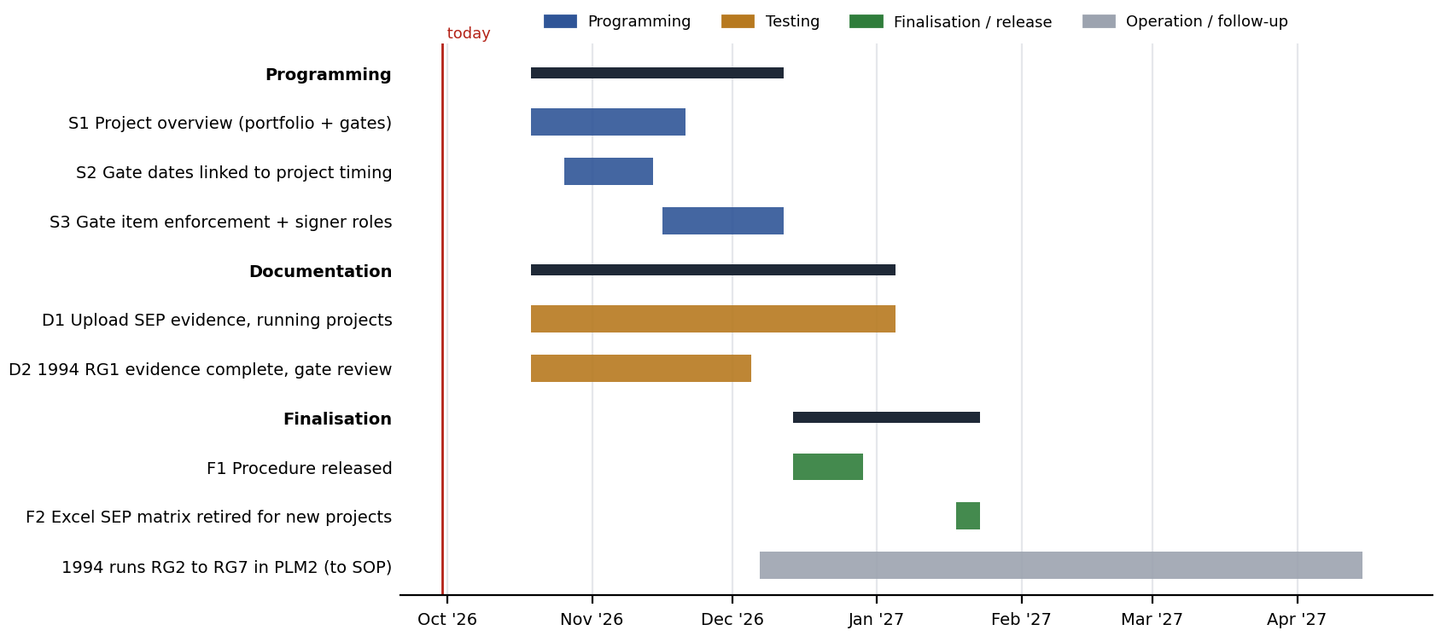
No. | Action | Phase | Owner | Support | Due | Done when
S1 | Project overview page (all projects, gates, overdue, open changes and lessons) | Programming | C. Demmler | Program Mgmt., APQP | 11/20/2026 | Page live, used in monthly review
S2 | Gate target dates linked to project timing, overdue signal | Programming | C. Demmler | Program Mgmt., APQP | 11/13/2026 | Dates set for all running projects
S3 | Required items per gate enforced; signer role per item | Programming | C. Demmler | Quality | 12/11/2026 | Gate close blocked in test
D1 | Upload SEP evidence for running projects (1864, 1994, 2141, 2277) | Documentation | C. Demmler | Program Mgmt., APQP | 01/04/2027 | Items done / n.a. with evidence
D2 | 1994: RG1 evidence complete, gate review with dual sign-off | Documentation | C. Demmler | Quality | 12/04/2026 | RG1 closed in PLM2
F1 | Procedure 'Project planning with the SEP matrix in PLM2' released | Finalisation | C. Demmler | Quality | 12/28/2026 | Procedure in document control
F2 | Excel SEP matrix retired for new projects | Finalisation | C. Demmler | Plant Mgmt. | 01/18/2027 | First new project started in PLM2
R1 | 1994 runs RG2 to RG7 in PLM2; gate dates from the Brose customer timing | Operation | Program Mgmt. | to SOP | Each gate closed with sign-off

The table is the plan as of the status date above. Progress is tracked in the action plan TOC-PLM-LOP (KTX LOP F-DVS-CORP-010); a date that moves is changed there with the reason, and this document is updated with it.
8. Control until go-live
Running projects keep their current SEP evidence valid while it is uploaded; the upload is tracked item by item in PLM2, so the open amount is visible at any time. Project 1994 runs in PLM2 from now on.
9. Effectiveness indicators
Indicator | Target | Source
Gates closed on or before target date | 90 % | Project overview
Required items closed without evidence file | 0 | SEP matrix
New projects started outside PLM2 after 01/18/2027 | 0 | Project list

